Course: CSE 204 – Computer Networks
LAB 1 – Introduction to Computer Networks
Due date: April 16th, 2025

Student name | Nguyen Xuan Huan
Student ID | 2131200077

Objectives
- Understanding Network configuration on Windows.
- Understanding commands used to configure and retrieve Network information.

Assignment List

II.1 Understanding Network configuration on Windows
- Run the command ipconfig /all to see the TCP/IP configuration.
- How many network adapters does your computer have? Answer: 3
- List the detail information of each network adapter.
  - Type of network adapter
  - IP address
  - Subnet mask
  - Default gateway
  - DNS server
- Take the screenshot of each adapter information and show the results below. Result:
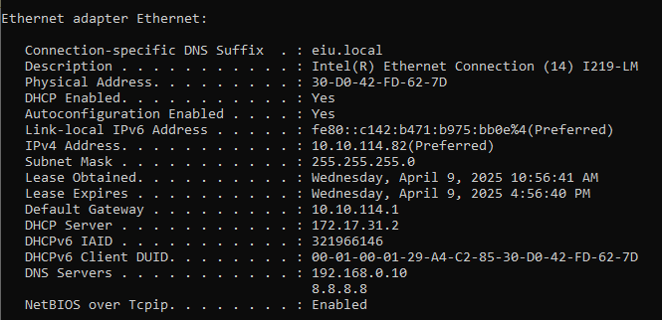
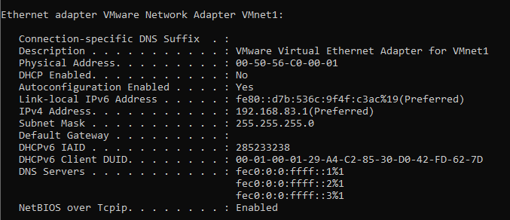
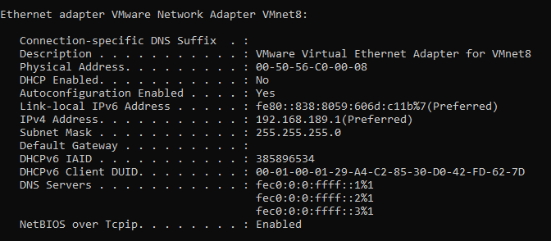

II.2 Understanding basic commands for Network information

ipconfig command
- What does this command do?
The ipconfig command is used in Windows to display the IP configuration details of the system. It shows the IP address, subnet mask, and default gateway of the system's network adapters. It can also be used with additional options to release or renew IP addresses for a network interface.
- Execute the command and take the screenshot of its output.
Result: 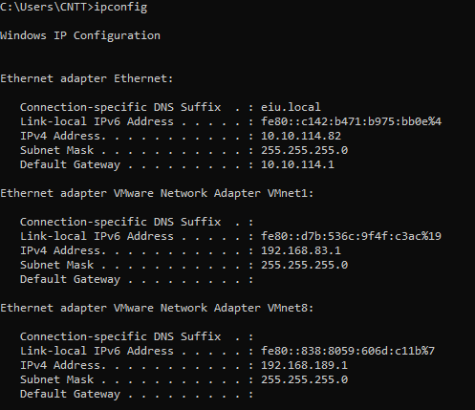

- Explain the output of this command.
The output typically includes:
- IPv4 Address: device's IP address on the local network.
- Subnet Mask: The network mask, which helps determine the size of the local network.
- Default Gateway: The router or gateway device uses to access the internet.
- Additional details may show other network interfaces, such as Ethernet or Wi-Fi connections.

netstat command
- What does this command do?
The netstat (network statistics) command provides detailed information about network connections on the system. It displays active TCP/UDP connections, open ports, routing tables, and network interfaces.
- Execute the command and take the screenshot of its output.
Result: 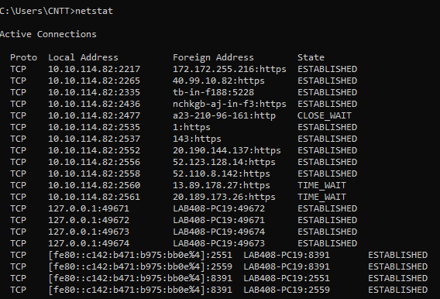

- Explain the output of this command.
The output typically includes:
- Active Connections: Lists the local IP address, remote IP address, and the status (e.g., ESTABLISHED, LISTENING).
- Proto: The protocol used (TCP or UDP).
- Local Address: The local IP and port.
- Foreign Address: The remote IP and port.
- State: The state of the connection, such as ESTABLISHED, TIME_WAIT, or CLOSE_WAIT.

tracert command
- What does this command do?
The tracert command (short for "trace route") is used to trace the path data packets take to reach a destination IP address or domain. It provides the sequence of hops (routers) and the time it takes for each hop to complete
- Execute the command “tracert www.google.com” and take the screenshot of its output.
- Result: 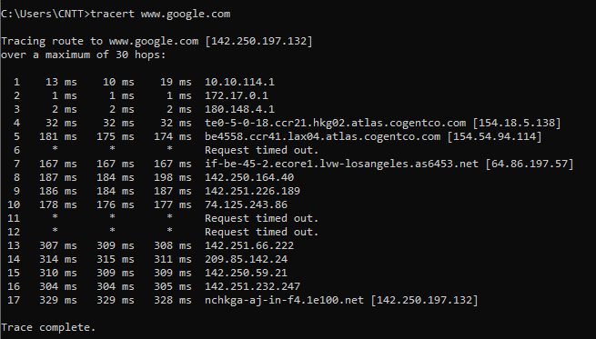.

- Explain the output of this command.
- The output lists each hop (router) that the packets travel through to reach the destination.
- Each hop shows the round-trip time (RTT) to that router, measured in milliseconds.
- If there is a timeout or packet loss, it will show an asterisk (*).
- The final destination is usually the server you're trying to reach (in this case, Google).

route command
- What does this command do?
The route command is used to display and manipulate the network routing tables on the system. It can show the routes that packets take to various destinations.
- Execute the command “route PRINT” and take the screenshot of its output. Result:
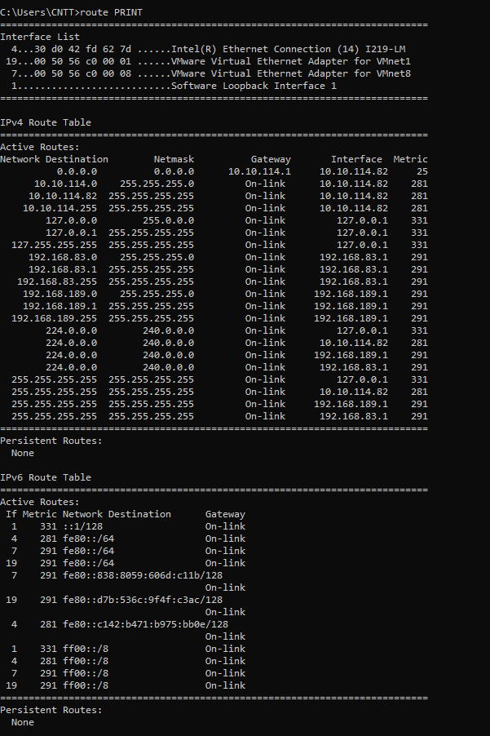
- Explain the output of this command.
The output typically includes:
- Network Destination: The target network.
- Netmask: The subnet mask for the target network.
- Gateway: The IP address of the next hop in the route.
- Interface: The local network interface used for the route.
- Metric: A value indicating the cost of the route, with lower values being preferred.

ping command
  - What does this command do?
The ping command is used to test the connectivity between your device and another device (usually a server) on the network. It sends packets to the destination and waits for a reply, measuring the time it takes for the reply to return
- Execute the following commands and take the screenshot of their outputs.
    - “ping www.google.com”
Result: 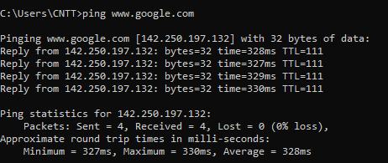

    - “ping www.eiu.edu.vn”
Result:
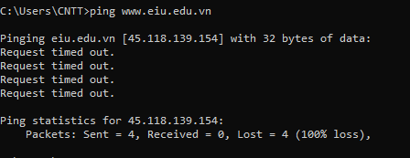

- Explain the output of this command.
The output shows the time it takes (in milliseconds) for each packet to travel to the target and back. It also indicates packet loss if any packets fail to reach the target or return.
- Reply from: The IP address and the round-trip time for each packet.
- Request Timed Out: Indicates that the target did not respond.

nslookup command
- What does this command do?
The nslookup command is used to query DNS (Domain Name System) servers to obtain domain name or IP address information. It helps to find the IP address associated with a domain name.
- Execute the command “nslookup www.eiu.edu.vn” and take the screenshot of its output. Result:
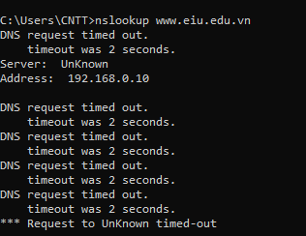

- Explain the result of this command.
The output typically shows:
- Server: The DNS server used to resolve the query.
- Address: The IP address of the DNS server.
- Non-authoritative answer: Shows the resolved IP address of the domain name.
- The domain name and its corresponding IP address are displayed.

II.3 Configure IP address on Windows clients
Requirements: 2 Windows virtual machines in VMWare Workstation

Configure IP address on Windows
- Instruction: Do the following steps
  - Open Start menu.
  - Search and open Control Panel.
  - Open Network and Internet.
  - Open Network and Sharing Center.
  - On the left panel, choose Change adapter settings.
  - Right click on the adapter you want to configure and choose Properties.
  - In the first tab, click on Internet Protocol Version 4 (TCP/IPv4) and then click Properties.
  - Click on Use the following IP address. Then, fill in the information as follows:
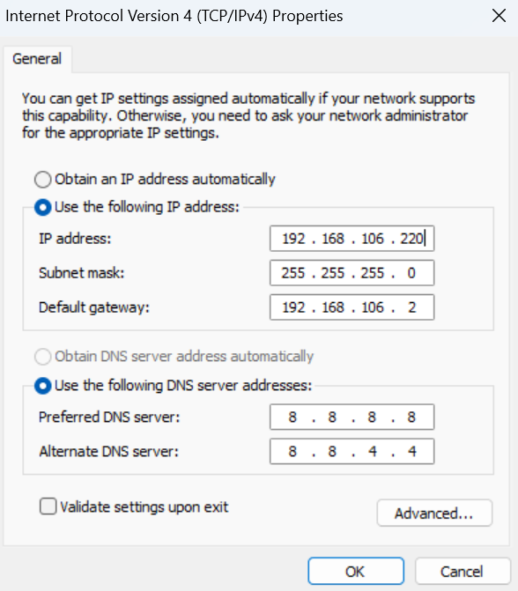
- After that, open Command Prompt and run the command “ipconfig” to check the result.
- Result:
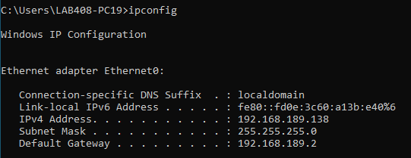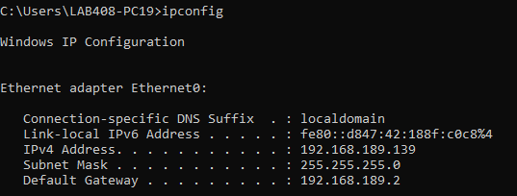

Test connectivity between 2 Windows Clients
- Case 1:
- Configure IP address of two clients:
  - Client #1: 192.168.1.x (Subnet Mask: 255.255.255.0)
  - Client #2: 192.168.1.y (Subnet Mask: 255.255.255.0)
  - Note: x and y MUST be different and in range 2-200
- Run the ping command in two clients. Results:
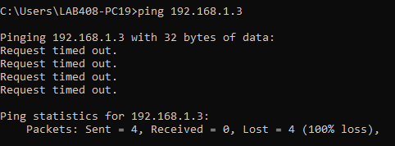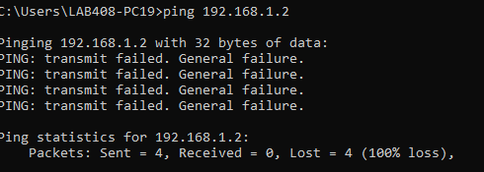
- Case 2
- Configure IP address of two clients:
  - Client #1: 192.168.1.x (Subnet Mask: 255.255.255.0)
  - Client #2: 10.10.114.y (Subnet Mask: 255.255.255.0)
  - Note: x and y MUST be different and in range 2-200
- Run the Ping command in two clients. Results:
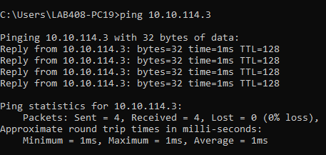
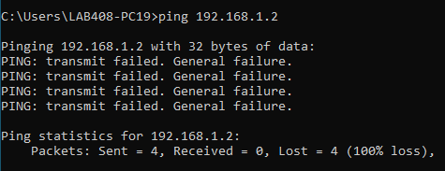

- Explain why.
Case 1 (Same Subnet):
- Both clients are on the same network (192.168.1.x), so they can communicate directly. The ping should succeed.
Case 2 (Different Subnets):
- Client #1 is in the 192.168.1.x subnet and Client #2 is in the 10.10.114.y subnet. Since they're in different subnets, they can't communicate directly without a router. The ping will fail unless a router is used to route traffic between the subnets.

